AIRLINE PERFORMANCE AND FLIGHT DELAY ANALYSIS
Python Data Analytics Project

Submitted by : Afifa Yasmin
Course : Data Analytics
Tools Used : Python, Pandas, Matplotlib, Seaborn
Academic Year: 2026

ABSTRACT
This project focuses on analysing airline performance and flight delays using Python. The main objective is to examine departure delays, arrival delays, flight cancellations, and flight diversions in a sample airline dataset.
The dataset initially contained 2,000 rows and 10 columns. Data cleaning was performed by checking missing values, handling missing data, removing duplicate records, and detecting and treating outliers using the Interquartile Range (IQR) method.
Exploratory Data Analysis (EDA) was conducted using Pandas. Data visualizations were created using Matplotlib and Seaborn, including airline-wise departure delay comparisons, arrival delay comparisons, cancellation and diversion counts, a correlation heatmap, and a departure delay distribution histogram with KDE.
The analysis helps identify patterns and differences among airlines in the sample dataset. The results are useful for understanding flight delay patterns, although they should not be considered official statistics for real-world airline performance.

TABLE OF CONTENTS
- Introduction
- Objectives of the Project
- Dataset Description
- Tools and Technologies Used
- Data Cleaning and Preprocessing
- Exploratory Data Analysis (EDA)
- Outlier Analysis
- Results and Visualizations
- Key Findings
- Conclusion
- Limitations
- References

1. INTRODUCTION
Airline performance analysis is an important part of understanding flight delays, cancellations, and diversions. Flight delays can affect passengers, airline operations, and overall customer satisfaction.
This project focuses on analysing airline performance using Python. The dataset contains information about airlines, flight distance, departure delay, arrival delay, flight duration, cancellations, diversions, origin, destination, and delay reasons.
Python libraries such as Pandas, Matplotlib, and Seaborn are used for data cleaning, analysis, and visualization. Charts are created to compare airline delays, cancellations, diversions, and the distribution of departure delays.
The main purpose of this project is to identify patterns in the sample dataset and present the findings through meaningful visualizations.

2. OBJECTIVES OF THE PROJECT
The main objectives of this project are:
- To analyse airline performance using Python.
- To identify average departure and arrival delays for different airlines.
- To analyse cancelled and diverted flights.
- To identify missing values and duplicate records in the dataset.
- To detect outliers in flight delay data using the IQR method.
- To study correlations between numerical variables.
- To visualize the results using Matplotlib and Seaborn.
- To present meaningful findings from the sample dataset.

3. DATASET DESCRIPTION
The dataset used in this project is a sample airline flight delay dataset containing 2,000 rows and 10 columns before data cleaning.
The dataset includes information about airlines, flight distance, departure delay, arrival delay, flight duration, cancellation status, diversion status, origin, destination, and delay reasons.
Dataset Columns:
- Airline – Name of the airline.
- Flight_Distance – Distance travelled by the flight.
- Departure_Delay – Delay at departure in minutes.
- Arrival_Delay – Delay at arrival in minutes.
- Flight_Duration – Total duration of the flight.
- Cancelled – Indicates whether a flight was cancelled.
- Diverted – Indicates whether a flight was diverted.
- Origin – Departure airport.
- Destination – Arrival airport.
- Delay_Reason – Reason for the flight delay.
After removing duplicate records, the cleaned dataset contained 1,990 rows and 10 columns.
Note: This is a sample dataset used for educational analysis. The results should not be interpreted as official statistics for the airlines.

4. TOOLS AND TECHNOLOGIES USED
The following tools and technologies were used to perform the airline performance analysis.
1. Python
Python was used as the main programming language for data analysis.
2. Google Colab
Google Colab was used to write and execute Python code in an online notebook environment.
3. Pandas
Pandas was used for data loading, data cleaning, handling missing values, removing duplicates, and performing data analysis.
4. Matplotlib
Matplotlib was used to create bar charts and other visualizations.
5. Seaborn
Seaborn was used to create statistical visualizations, including the correlation heatmap and histogram with KDE.

5. DATA CLEANING AND PREPROCESSING
Data cleaning is an important step in data analysis. It helps improve data quality and makes the dataset suitable for further analysis.
The following data cleaning steps were performed in this project:
1. Loading the Dataset
The airline dataset was loaded into Python using the Pandas library.
2. Checking Dataset Information
The shape, column names, data types, and statistical summary were examined using Pandas functions.
3. Handling Missing Values
Missing values in numerical columns were handled using the median. Missing values in the Delay_Reason column were filled with the label "Late Aircraft".
4. Removing Duplicate Records
Duplicate records were identified and removed. The dataset was reduced from 2,000 rows to 1,990 rows.
5. Outlier Detection
The Interquartile Range (IQR) method was used to identify outliers in departure and arrival delays. The detected delay outliers were capped using the IQR limits.
After these steps, the cleaned dataset was used for exploratory data analysis and visualization.
Note: Filling missing Delay_Reason values with "Late Aircraft" may increase the count of this category and should be considered when interpreting the results.

6. EXPLORATORY DATA ANALYSIS (EDA)
Exploratory Data Analysis (EDA) was performed to understand the patterns and characteristics of the cleaned airline dataset.
The following analyses were carried out:
1. Airline-wise Departure Delay Analysis
The average departure delay was calculated for each airline to compare departure performance.
2. Airline-wise Arrival Delay Analysis
The average arrival delay was calculated for each airline to understand differences in arrival performance.
3. Cancellation Analysis
Cancelled flights were counted for each airline to identify differences in cancellation counts.
4. Diversion Analysis
Diverted flights were counted for each airline to compare diversion counts.
5. Correlation Analysis
A correlation heatmap was created to examine relationships between numerical variables in the dataset.
6. Departure Delay Distribution
A histogram with a Kernel Density Estimate (KDE) was used to visualize the distribution of departure delays.
These analyses helped summarize airline performance patterns in the sample dataset.

7. OUTLIER ANALYSIS
7.1 Introduction to Outlier Analysis
Outlier analysis is an important step in data preprocessing. An outlier is a data point that differs significantly from most other observations in a dataset. In airline data, unusually high departure or arrival delays may be identified as outliers.
These extreme values can affect statistical measures such as the mean and standard deviation. Therefore, outlier detection was performed to understand the distribution of flight delays and prepare the dataset for further analysis.
7.2 Method Used for Outlier Detection
The Interquartile Range (IQR) method was used to identify outliers in the numerical columns.
The IQR represents the difference between the third quartile (Q3) and the first quartile (Q1).
The formulas used are:
- IQR = Q3 − Q1
- Lower Bound = Q1 − 1.5 × IQR
- Upper Bound = Q3 + 1.5 × IQR
Values below the lower bound or above the upper bound are classified as potential outliers.
The IQR method is useful because it is based on quartiles and is less sensitive to extreme values than methods that rely on the mean and standard deviation.
7.3 Outlier Detection Results
The IQR method was applied to the numerical columns in the airline dataset. The following results were obtained before outlier treatment.
Numerical Column | Number of Outliers
Departure_Delay | 9
Arrival_Delay | 14
Flight_Distance | 0
Flight_Duration | 0
The analysis identified 9 outliers in departure delays and 14 outliers in arrival delays. No outliers were detected in flight distance or flight duration using the IQR method.
The results indicate that extreme values were present in the delay columns. These values may represent flights experiencing unusually long delays in the sample dataset.
7.4 Outlier Treatment
After detecting the outliers, the identified departure and arrival delay values were capped using the IQR lower and upper bounds.
Capping replaces values outside the calculated limits with the corresponding boundary value. This reduces the influence of extreme observations without removing the entire flight record from the dataset.
The treatment was applied to prepare the delay data for subsequent statistical analysis and visualization.
7.5 Importance of Outlier Analysis
Outlier analysis was useful in this project for the following reasons:
- It helped identify unusually high or low flight delay values.
- It provided a better understanding of the distribution of departure and arrival delays.
- It reduced the influence of extreme delay values on subsequent analysis.
- It helped prepare the dataset for further visualization and interpretation.
7.6 Conclusion
The IQR method identified outliers in departure and arrival delays, while no outliers were detected in flight distance or flight duration. The identified delay outliers were capped using the IQR limits.
This step supported the data preprocessing process and helped prepare the dataset for further airline performance analysis.
Important note: Outliers are not necessarily incorrect data. In airline operations, unusually long delays may represent genuine events. Therefore, capping these values can make extreme delays appear smaller than they originally were. The outlier treatment should be considered when interpreting the final results.

8.RESULTS AND VISUALIZATIONS
Data visualization was used to understand and present the result of the airline performance analysis.six charts were created using python libraries such as Matplotlib and Seaborn. Each charts is explained below with its interpretation.

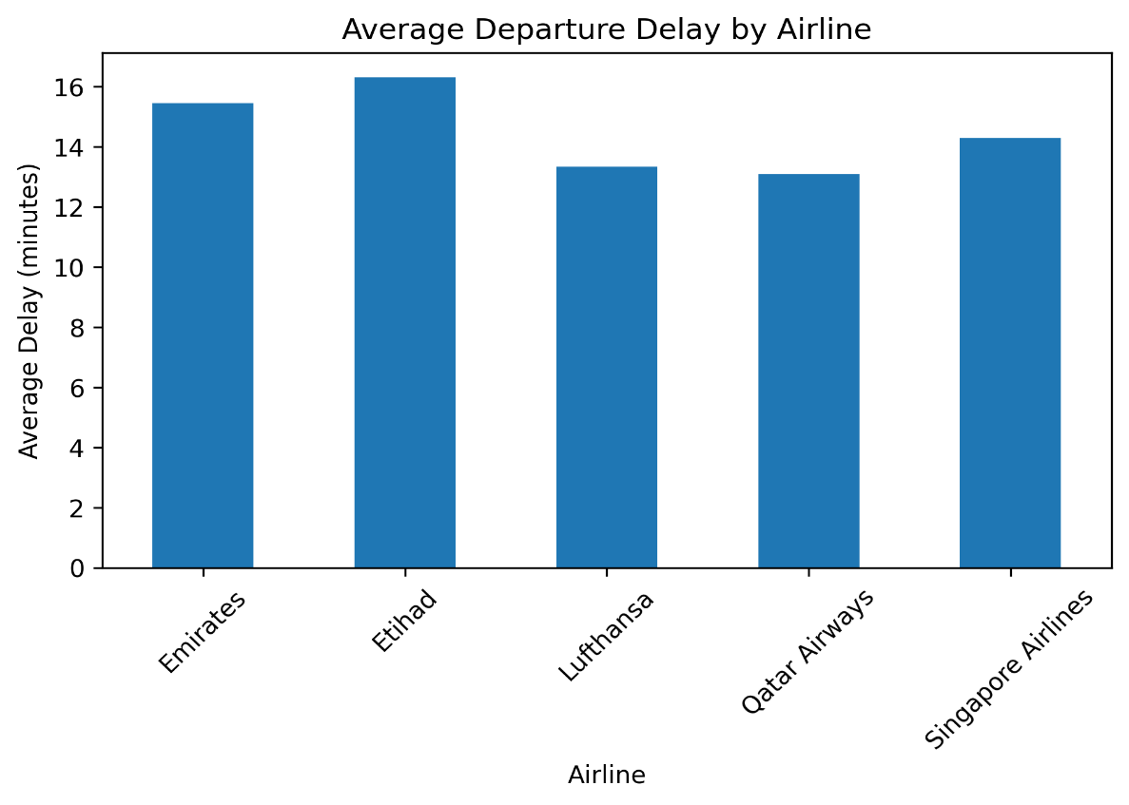
8.1 Average Departure Delay by Airline
Description:
This bar chart compares the average departure delay among different airlines in the sample dataset. The average departure delay was calculated for each airline to understand differences in departure performance.
Interpretation:
The analysis showed that Etihad Airways had the highest average departure delay, approximately 16.31 minutes, while Qatar Airways had the lowest average departure delay, approximately 13.09 minutes, in this sample dataset.
The chart helps identify differences in departure delay patterns among the airlines included in the analysis.

.

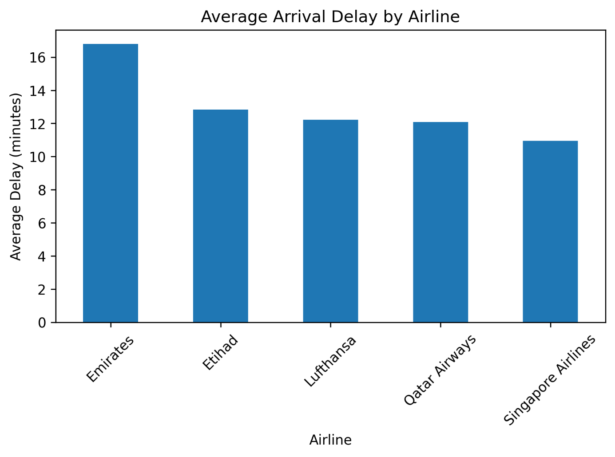

8.2 Average Arrival Delay by Airline
Description:
This bar chart compares the average arrival delay across different airlines in the sample dataset. It helps identify differences in arrival delay patterns among the airlines.
Interpretation:
The analysis showed that Emirates had the highest average arrival delay, approximately 16.79 minutes, while Singapore Airlines had the lowest average arrival delay, approximately 10.95 minutes, in this sample dataset.
The results indicate that average arrival delays varied among the airlines. Comparing arrival delays helps us understand differences in flight arrival performance within the dataset.
Figure 2: Average Arrival Delay by Airline

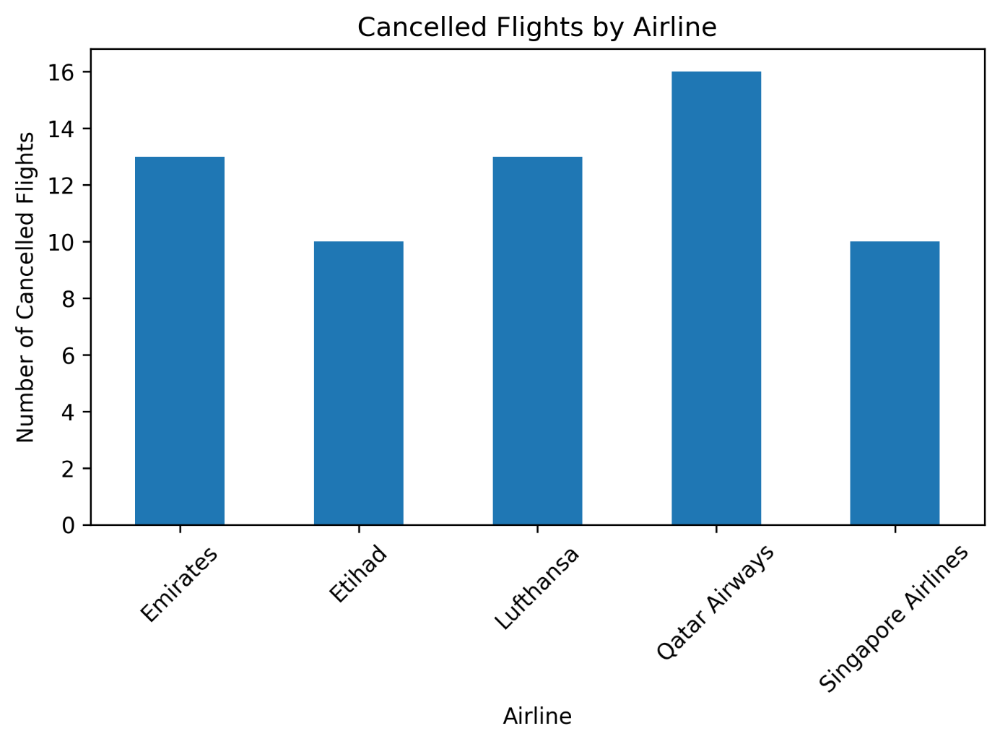

8.3 Cancelled Flights by Airline
Description:
This chart shows the number of cancelled flights for each airline in the sample dataset. It helps compare cancellation counts and identify which airlines had more cancelled flights in the analysed data.
Interpretation:
The analysis showed that Qatar Airways had the highest cancellation count, with 16 cancelled flights in the sample dataset.
Comparing cancellation counts helps us understand how cancellations were distributed among the airlines. However, these counts alone do not indicate which airline has the highest cancellation rate, because the total number of flights operated by each airline may differ.

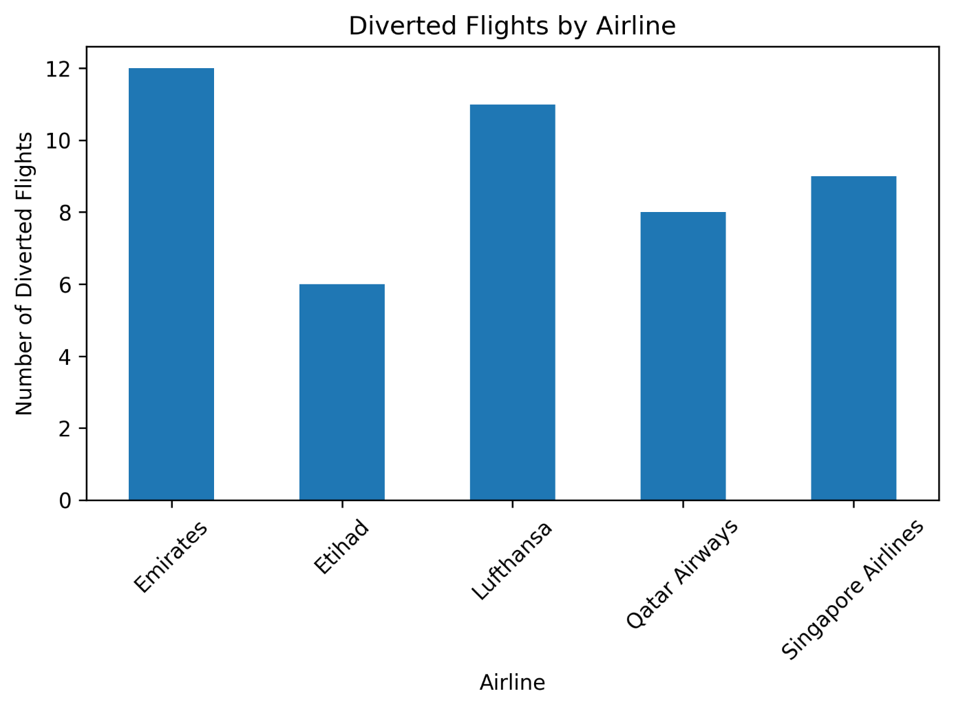

8.4 Diverted Flights by Airline

Description:

This chart illustrates the number of diverted flights for each airline in the sample dataset. A flight diversion occurs when an aircraft lands at an airport other than its originally planned destination. The chart helps compare diversion counts across the airlines included in the analysis.

Interpretation:

The analysis showed that Emirates had the highest diversion count, with 12 diverted flights in the sample dataset. The chart provides an overview of how diverted flights were distributed among the airlines.

However, the number of diverted flights alone does not indicate the diversion rate of each airline, because the total number of flights operated by each airline may differ.

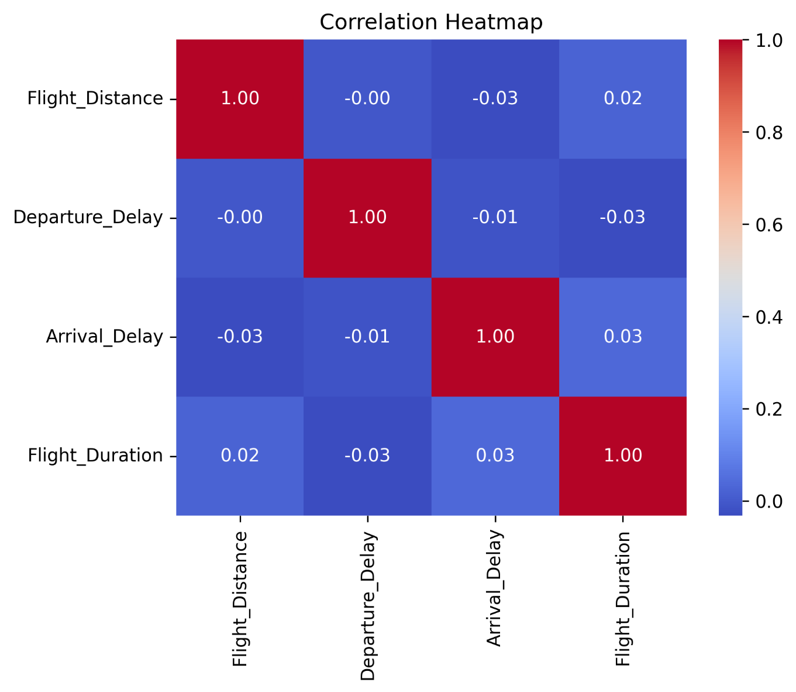
8.5 Correlation Heatmap

Description:

A correlation heatmap was created to examine the relationships between numerical variables in the airline dataset. Correlation measures the strength and direction of the relationship between two numerical variables.

The heatmap uses different colours to represent correlation values. Values close to +1 indicate a strong positive relationship, values close to -1 indicate a strong negative relationship, and values close to 0 indicate a weak linear relationship.

Interpretation:

The correlation analysis showed that most numerical variables had correlations close to zero in the sample dataset. This suggests that most pairs of numerical variables did not have strong linear relationships.

The heatmap provides a visual summary of the relationships between numerical variables and helps identify patterns for further investigation.

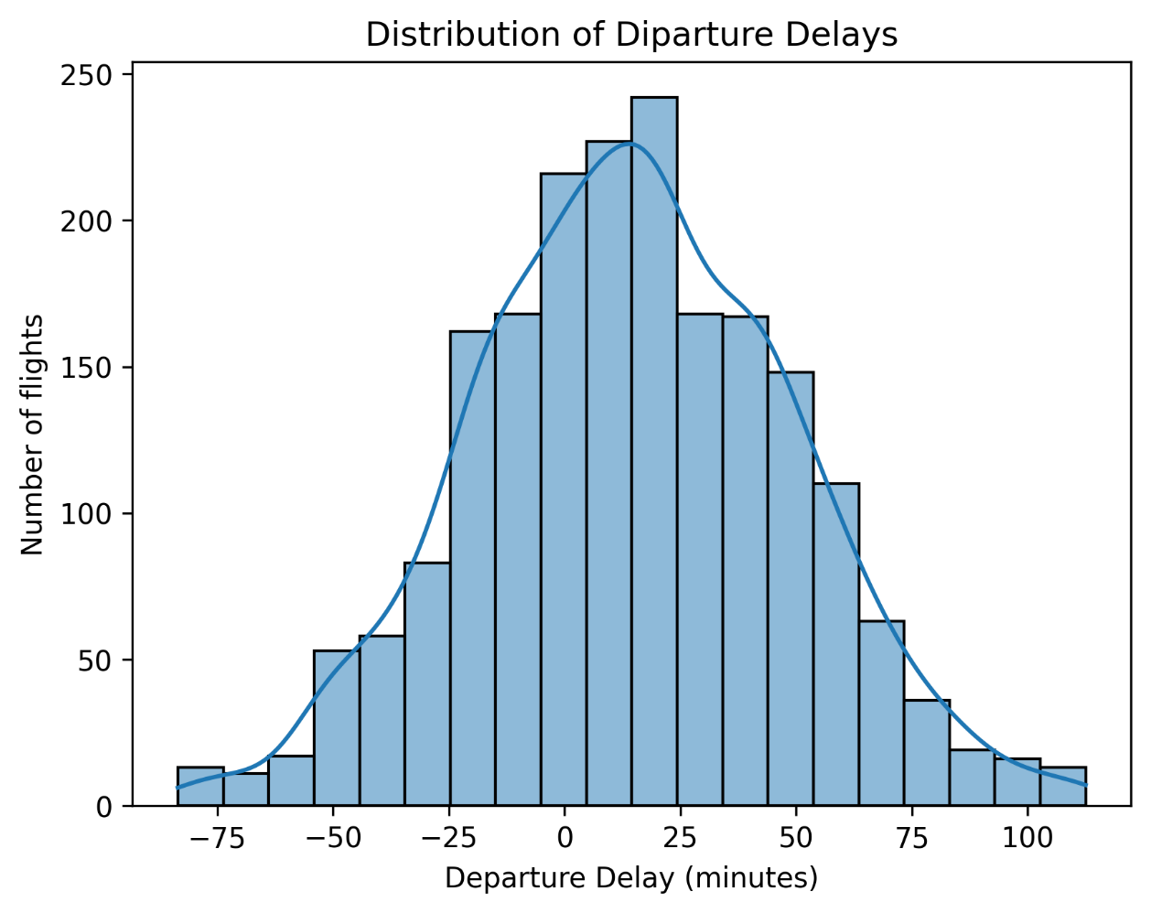

8.6 Distribution of Departure Delays (Histogram with KDE)

Description:

A histogram with a Kernel Density Estimate (KDE) curve was used to examine the distribution of departure delays in the sample airline dataset.

The histogram displays the frequency of departure delay values using bars, while the KDE curve provides a smooth representation of the distribution. This visualization helps us understand how departure delays are spread across the dataset.

Interpretation:

The chart helps identify the common ranges of departure delays and shows how frequently different delay values occur. The shape of the distribution can also help reveal whether the data is concentrated within particular ranges or contains extreme values.

This visualization provides a better understanding of departure delay patterns and supports the overall airline performance analysis.

9. KEY FINDINGS

The airline performance analysis produced the following key findings from the sample dataset:

1. Departure Delay Analysis

Etihad Airways recorded the highest average departure delay of approximately 16.31 minutes, while Qatar Airways recorded the lowest average departure delay of approximately 13.09 minutes.

2. Arrival Delay Analysis

Emirates recorded the highest average arrival delay of approximately 16.79 minutes, while Singapore Airlines recorded the lowest average arrival delay of approximately 10.95 minutes.

3. Flight Cancellation Analysis

Qatar Airways had the highest number of cancelled flights, with 16 cancellations in the sample dataset.

4. Flight Diversion Analysis

Emirates had the highest number of diverted flights, with 12 diversions in the sample dataset.

5. Correlation Analysis

Most numerical variables showed correlations close to zero, indicating generally weak linear relationships between those variables.

6. Outlier Analysis

The IQR method identified 9 outliers in Departure_Delay and 14 outliers in Arrival_Delay before treatment. No outliers were detected in Flight_Distance or Flight_Duration using this method.

Overall, the analysis helped identify differences in delays, cancellations, diversions, and numerical relationships among the airlines represented in the sample dataset.

10. CONCLUSION

This project focused on analysing airline performance and flight delays using Python. The analysis was performed on a sample dataset containing information about airlines, departure delays, arrival delays, flight cancellations, flight diversions, flight distance, flight duration, and delay reasons.

Data cleaning and preprocessing were carried out to handle missing values, remove duplicate records, and detect and treat outliers using the Interquartile Range (IQR) method.

Exploratory Data Analysis (EDA) was performed to understand the characteristics and patterns within the dataset. Six visualizations were used to compare average departure delays, average arrival delays, cancelled flights, diverted flights, numerical correlations, and the distribution of departure delays.

The findings showed differences in average delays, cancellation counts, and diversion counts among the airlines represented in the sample dataset. The visualizations helped present these patterns in a clear and understandable way.

Overall, this project improved the understanding of data cleaning, exploratory data analysis, statistical methods, and data visualization using Python libraries such as Pandas, Matplotlib, and Seaborn.

The project demonstrates how Python can be used to analyse flight data and communicate findings through visualizations. However, the results are limited to the sample dataset and should not be treated as official statistics about real-world airline performance.

11. LIMITATIONS

Although this project provides useful insights into airline performance and flight delays, several limitations should be considered when interpreting the results.

1. Sample Dataset

The analysis was conducted using a sample dataset containing 2,000 rows initially. Therefore, the findings may not represent the actual performance of airlines worldwide.

2. Missing Values

Missing values were present in the dataset. Numerical missing values were handled using the median, while missing values in the Delay_Reason column were filled with "Late Aircraft". This may have increased the count of this delay reason and affected the interpretation of delay categories.

3. Outlier Treatment

The IQR method was used to detect outliers in departure and arrival delays. The identified outliers were capped using the IQR limits. As a result, some extreme delay values may appear smaller than their original values.

4. Limited Variables

The dataset contains only 10 columns. Other factors that may influence flight delays, such as weather conditions, air traffic congestion, airport capacity, and seasonal variations, were not included.

5. Limited Time Information

The dataset does not provide sufficient time-based information to analyse seasonal trends or changes in airline performance over different periods.

6. Cancellation and Diversion Counts

The analysis compared cancellation and diversion counts among airlines. However, differences in the total number of flights operated by each airline may affect these comparisons.

7. Correlation Analysis

Correlation analysis identifies linear relationships between numerical variables but does not establish cause-and-effect relationships.

In conclusion, these limitations should be considered when interpreting the findings. Further analysis using larger, more detailed, and representative datasets could provide a more comprehensive understanding of airline performance.
12. REFERENCES

1. Python Software Foundation. Python Documentation.
https://docs.python.org/3/

2. Pandas Development Team. Pandas Documentation.
https://pandas.pydata.org/docs/

3. Matplotlib Development Team. Matplotlib Documentation.
https://matplotlib.org/stable/

4. Seaborn Development Team. Seaborn Documentation.
https://seaborn.pydata.org/

5. Google Colab. Google Colaboratory.
https://colab.research.google.com/

6. Airline Flight Delay Dataset used for this project.
Sample dataset containing 2,000 rows and 10 columns, used for educational data analysis.

